**SONARQUBE INSTALLATION**

**SONARQUBE**

**SonarQube** collects and analyzes source code, measuring quality and providing reports for your projects. It combines static and dynamic analysis tools and enables quality to be measured continuously overtime.  Everything that affects our code base, from minor styling details to critical design errors, is inspected and evaluated by SonarQube, thereby enabling developers to access and track code analysis data ranging from styling errors, potential bugs, and code defects to design inefficiencies, code duplication, lack of test coverage, and excess complexity.

SonarQube's greatest asset is that it provides fully automated analysis and integration with [Maven](https://en.wikipedia.org/wiki/Apache_Maven), [Ant](https://en.wikipedia.org/wiki/Apache_Ant), [Gradle](https://en.wikipedia.org/wiki/Gradle), [MS Build](https://en.wikipedia.org/wiki/MSBuild) and [continuous integration](https://en.wikipedia.org/wiki/Continuous_integration) tools ([Atlassian Bamboo](https://en.wikipedia.org/wiki/Bamboo_(software)), [Jenkins](https://en.wikipedia.org/wiki/Jenkins_(software)), [Hudson](https://en.wikipedia.org/wiki/Hudson_(software)), etc.). SonarQube also integrates with [Eclipse](https://en.wikipedia.org/wiki/Eclipse_(software)), [Visual Studio](https://en.wikipedia.org/wiki/Microsoft_Visual_Studio) and [IntelliJ IDEA](https://en.wikipedia.org/wiki/IntelliJ_IDEA) development environments through the SonarLint plugins and integrates with external tools like [LDAP](https://en.wikipedia.org/wiki/LDAP), [Active Directory](https://en.wikipedia.org/wiki/Active_Directory), [GitHub](https://en.wikipedia.org/wiki/GitHub), etc.

**PRE-REQUISITES**

* **Java Development Kit** (jdk) preferably versions 7 and up. In case you haven’t downloaded jdk here is the link you can use to download: http://www.oracle.com/technetwork/java/javase/downloads/index.html
* A proper internet connection

**INSTALLATION**

Here we need to install SonarQube and its compatible Sonar Scanner version. I have installed the following versions:  
**SonarQube version 5.4**: https://www.sonarqube.org/downloads/

**Sonar Scanner version 2.6.1**: https://javalibs.com/artifact/org.sonarsource.scanner.cli/sonar-scanner-cli

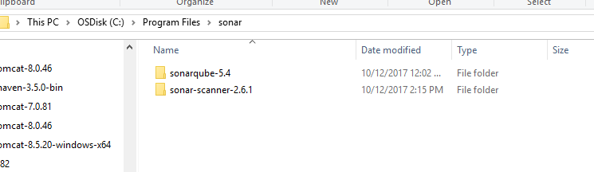

**SET ENVIRONMENT VARIABLE PATH:**

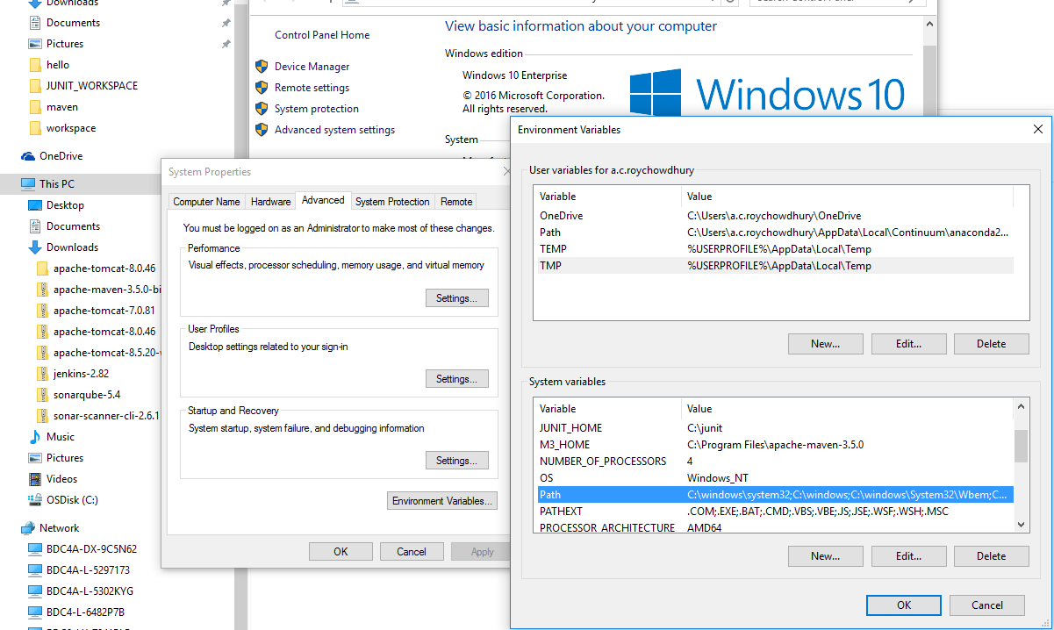

**Right Click on THIS PC- Advanced system settings - Environment Variables – Double click Path (under System Variables)**

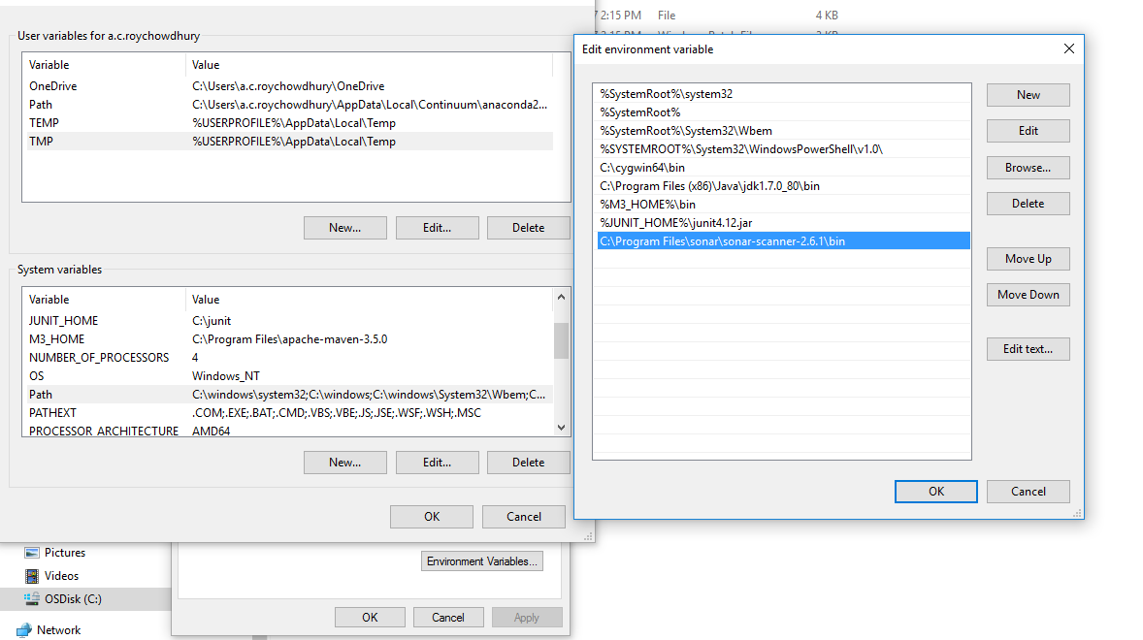

**Open the Sonar Scanner bin and set it as one of the system variables Path in the environment variables as shown in the above figures.**

**HOW TO START THE SONARQUBE IN OUR SYSTEM**

**When we want to run the sonar as long as the command prompt is open**

We can start the system in the command prompt by going to the path C:\Program Files\sonar\sonarqube-5.4\bin\windows-x86-32 and running the StartSonar.bat file or just go this file path and double click on the StartSonar batch file.

**\*\*\*** In case while starting the service they show some error like “access is denied” then we have to run the command prompt as the Administrator.

To so (for Windows 10 )

**Click on the start button - Right click on Command prompt - More - Run as Administrator**

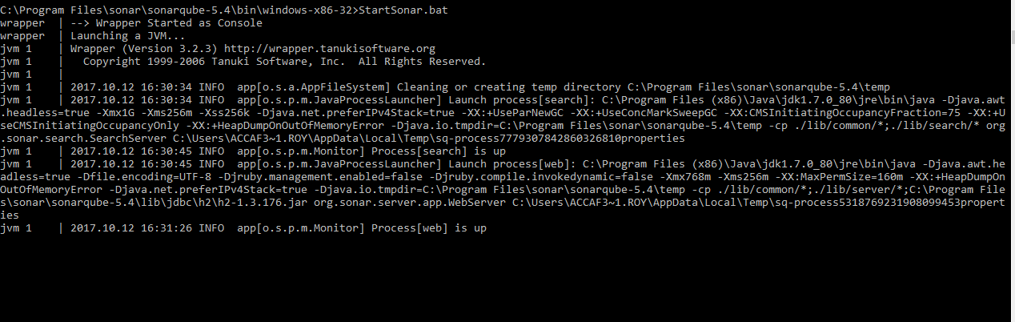

**TO RUN SONARQUBE AS A WINDOWS SERVICE:**

Most of the time to run the batch files you have to run the command prompt as a administrator

Then we open the bin path of the SonarQube and run the InstallNTService batch file first for installing it and then the StartNTService batch file to start the service.

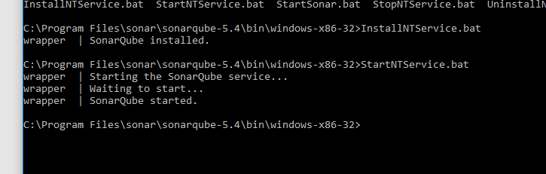

After this SonarQube will run as a service in your system.

It will start running and we can open the service in the port 9000(by default)

URL: **http://localhost:9000/**

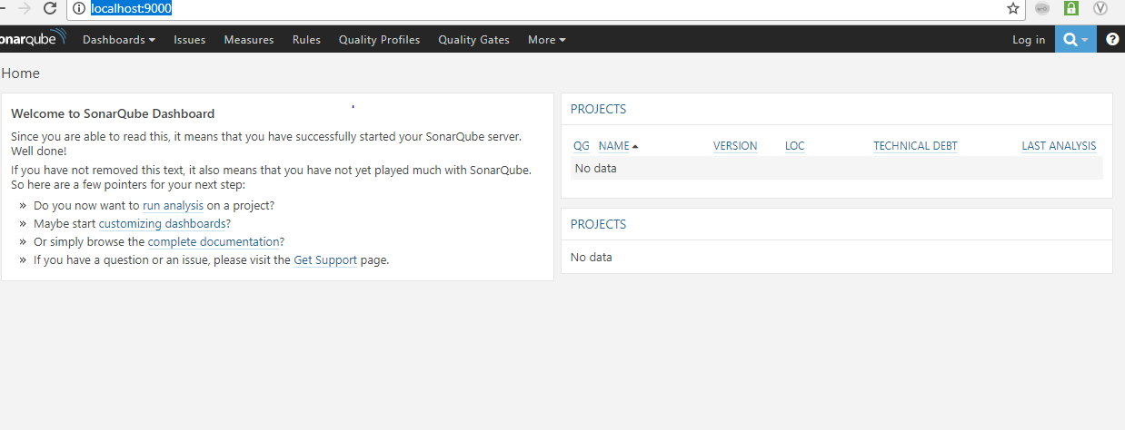

**JAVA INSTALLATION**

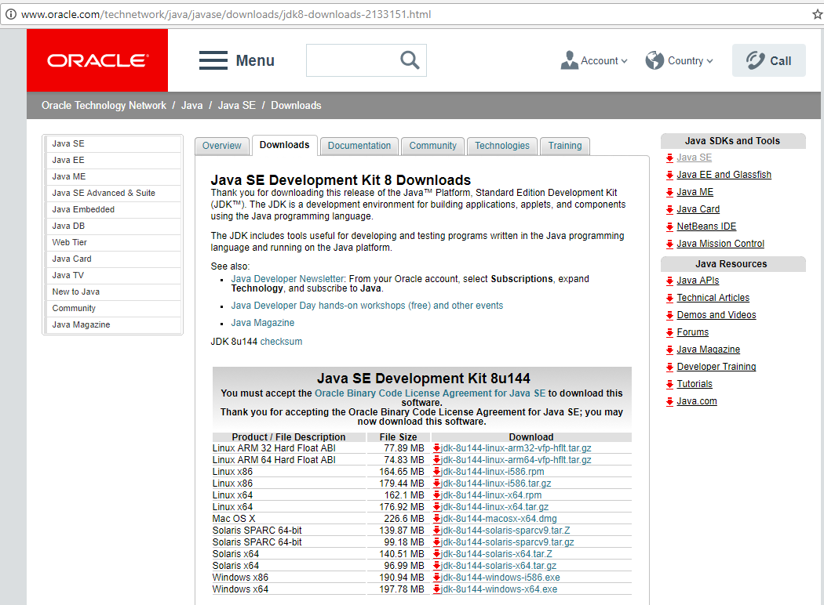

Here I have installed Java version 8 for Windows64 bit

<http://www.oracle.com/technetwork/java/javase/downloads/jdk8-downloads-2133151.html> - to download java in your system

After the installation is over complete the steps as follows and Finish it.  
A Java Folder gets created in Program Files inside which it will have both the JDK and JRE folders(as shown below)

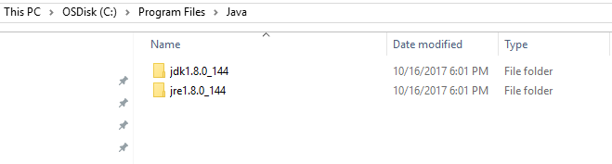

Now we need to add **JAVA_HOME= C:\Program Files\Java\jdk1.8.0_144** as a environment variable

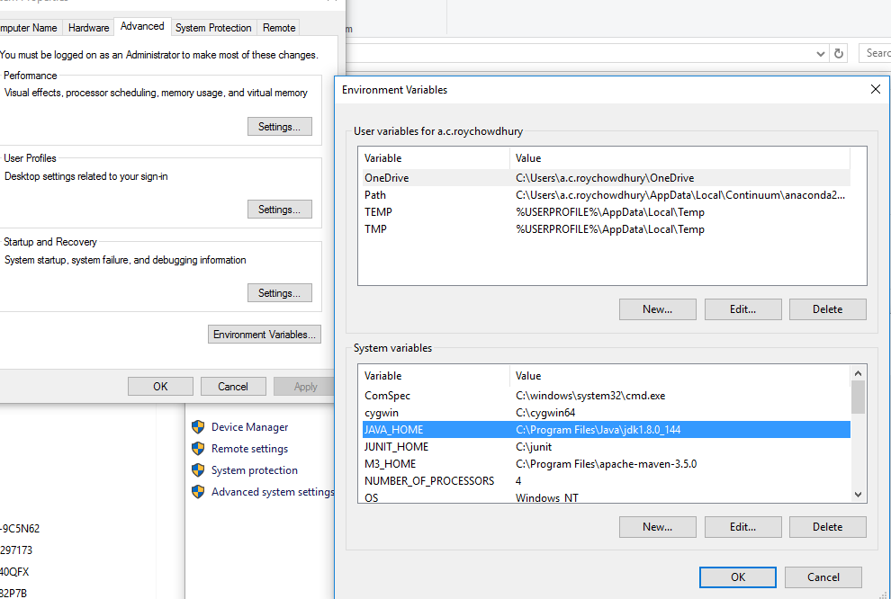

We also need to add the bin path of the JDK in the **PATH** variable**= C:\Program Files\Java\jdk1.8.0_144\bin** (as shown below)

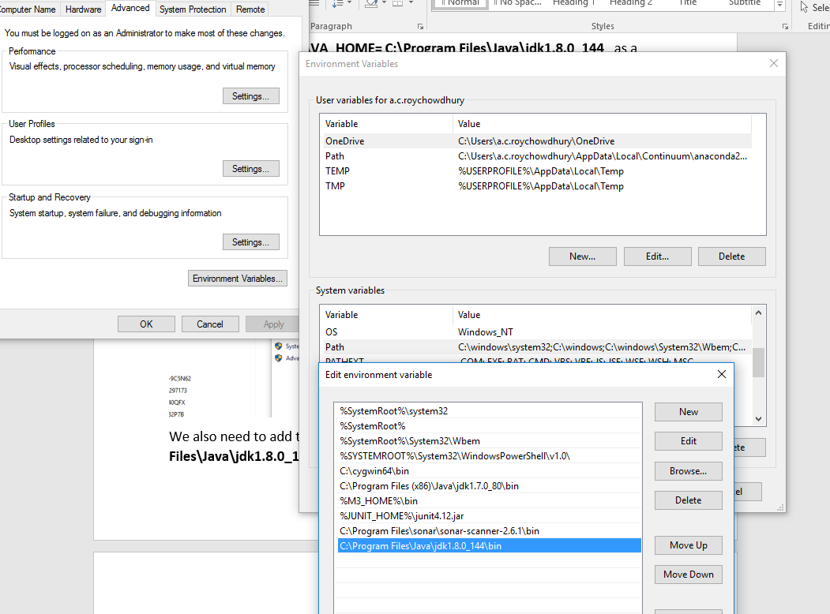

To check whether java is successfully installed in your system or not , Go to Command Prompt and type **java -version**

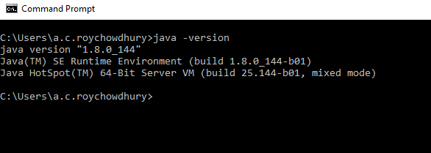Thus, java is installed in your system.  
  
**JENKINS INSTALLATION**

**WHAT IS JENKINS**

Jenkins is an open source automation tool written in Java with plugins built for Continuous Integration purpose. Jenkins triggers a build for every change made in the source code repository for example Git repository. Once the code is built it deploys it on the test server for testing. Concerned teams are constantly notified about build and test results. Finally, Jenkins deploys the build application on the production server.

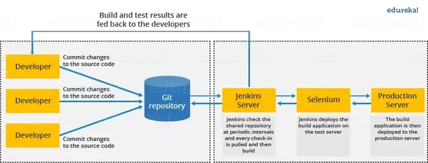

System Requirements

|  |  |
| --- | --- |
| JDK | JDK 1.5 or above |
| Memory | 2 GB RAM (recommended) |
| Operating System Version | Jenkins can be installed on Windows, Ubuntu/Debian, Red Hat/Fedora/CentOS, Mac OS X, openSUSE, FReeBSD, OpenBSD, Gentoo. |

**INSTALLATION**

<https://jenkins.io/download/>

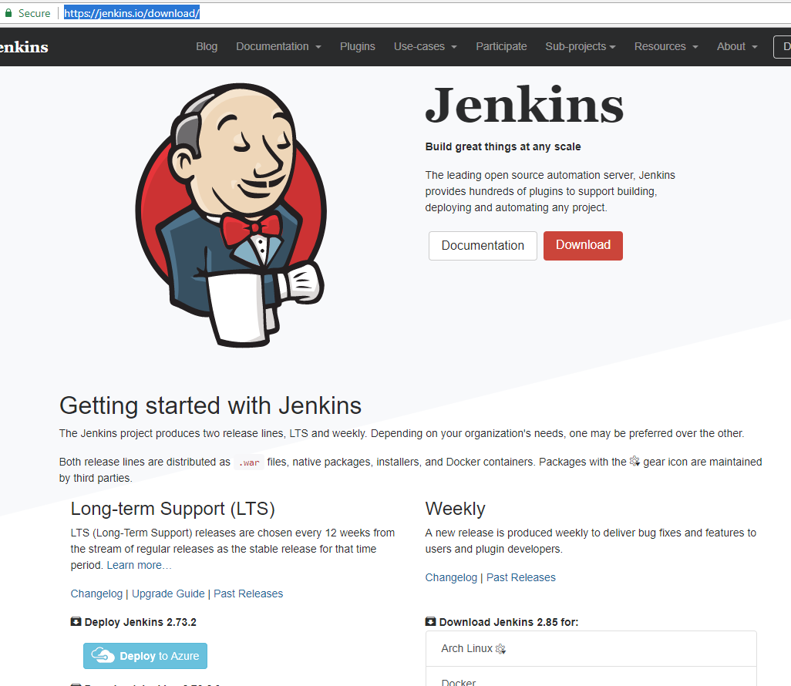

Here I will be running Jenkins as a Windows Service,

If we are running a production installation of Jenkins on a Windows box, it is essential to have it running as a Windows service. This way, Jenkins will automatically start whenever the server reboots, and can be managed using the standard Windows administration tools.  
At first go to the above mentioned link and download the required version   
Here after the downloading is complete ,we need to start the Jenkins server on your target machine. The simplest approach is install by copying the installation setup file in the desktop and start the installation by clicking on NEXT button and finally FINISH.

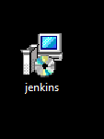

We can also install It from the command prompt, go the path where Jenkins folder is created , and type   
 **C:\jenkins>** **Java –jar Jenkins.war**

Once the processing is complete without major errors, the following line will come in the output of the command prompt.

**INFO: Jenkins is fully up and running**

Once Jenkins is up and running, one can access Jenkins from the link − <http://localhost:8080>(by default the port is 8080)This link will bring up the Jenkins dashboard.

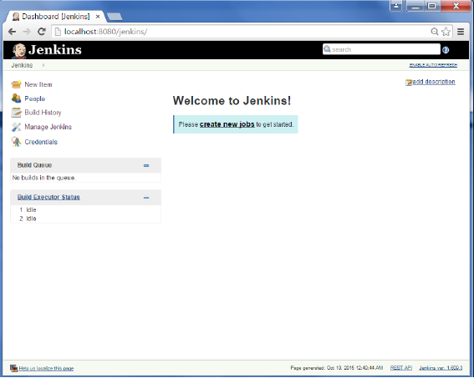

 If we have installed Jenkins using the windows installer, we need not do anything else because the windows installer automatically runs Jenkins as a windows service.   
We can confirm that by going to SERVICES in your system and checking whether JENKINS is there or not. (as shown below)

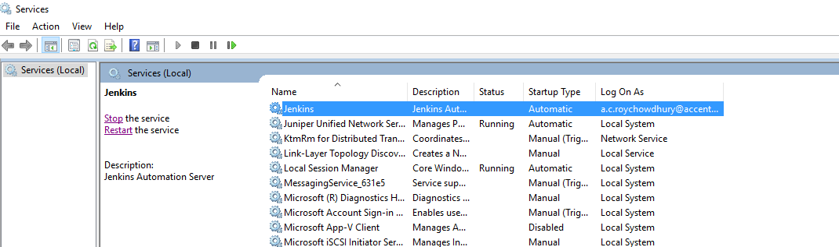

Later on we can Start, Stop or Restart our services from here also and also from the command prompt as well.

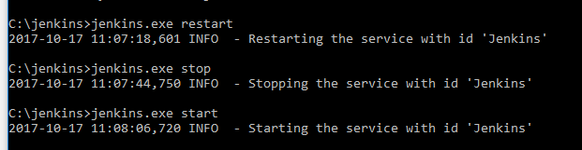  
Incase while trying to do so if it shows any error like:

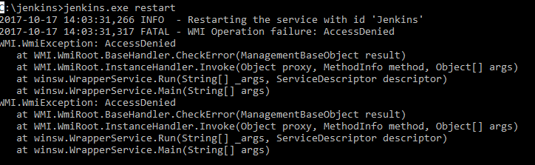

**This means you have to run the Command Prompt as an Administrator**.

Those you have installed Jenkins using Command Prompt , must know that your Jenkins will stop running once you close the CMD . So now we have to set it as a windows service. For that see the steps below:  
Open the dashboard in the left side of the screen you will see an option **MANAGE JENKINS**

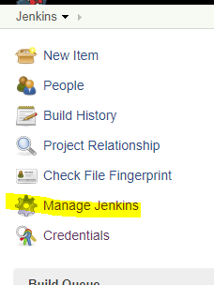

Click on it and it will open another page ,

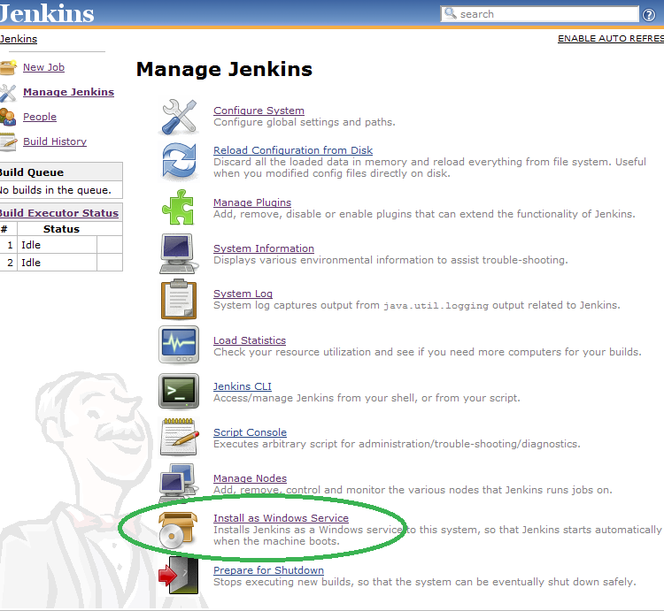

There is an option encircled in green **INSTALL AS WINDOWS SERVICE**Clicking this link shows you the installation screen:

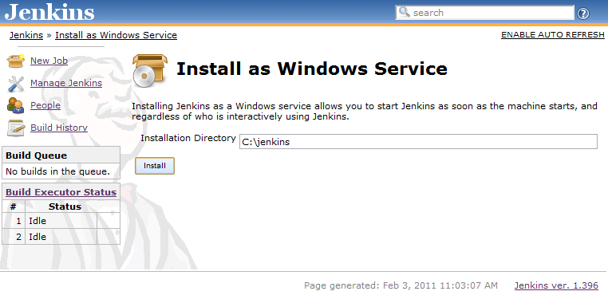

We need to choose the directory where Jenkins shall be installed (directory must already exist. If not create it before hand). This will become JENKINS_HOME and used to store data files and programs alike.  
Upon successful completion of the installation, we will see a page asking to restart Jenkins.   
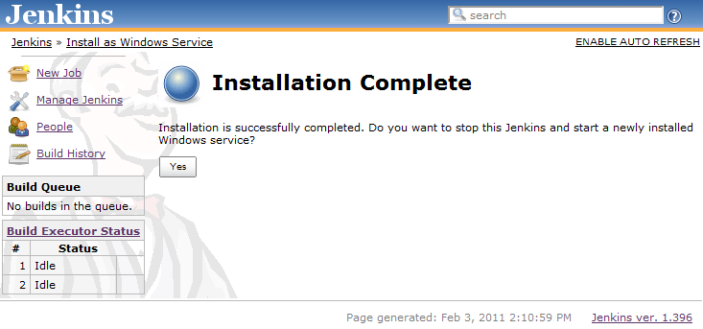

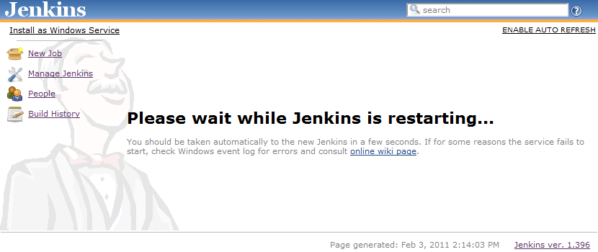

**\*\*\***While trying to download Jenkins from the Command Prompt if it shows error it can be due to many reasons. Below I will be mentioning some of the errors I came across

1.Do check whether your java is installed or not.

2.The port 8080 (by default) must already be used by some other.

3. Some time you need to run the CMD as an Administrator, it works only then.

4. In the service, you need to enter your own credentials to make it work

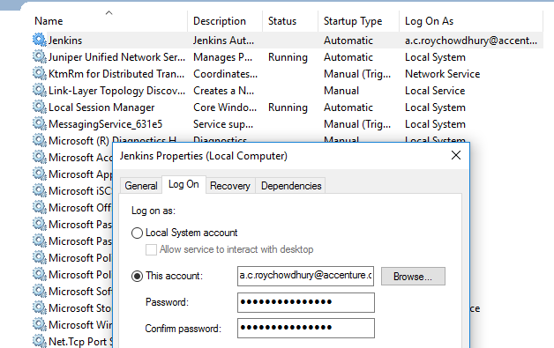

**APACHE MAVEN INSTALLATION  
  
Maven** is a [build automation](https://en.wikipedia.org/wiki/Build_automation) tool used primarily for [Java](https://en.wikipedia.org/wiki/Java_(programming_language)) projects. Maven addresses two aspects of building software: first, it describes how software is built, and second, it describes its dependencies.In other words, Maven is a project management and comprehension tool that provides developers a complete build lifecycle framework. Development team can automate the project's build infrastructure in almost no time as Maven uses a standard directory layout and a default build lifecycle. **The primary goal of Maven** is to provide developer with the following −  
 1. A comprehensive model for projects, which is reusable, maintainable, and easier to comprehend.  
2. Plugins or tools that interact with this declarative model.  
Maven project structure and contents are declared in an xml file, pom.xml, referred as **Project Object Model (POM),** which is the fundamental unit of the entire Maven system.

**PREREQUISITES:**1. We need to check whether Java 1.7 or above is installed in your system or not.  
If yes check whether its path is set as an environment variable or not and also add its path to the system path.

2. Download Apache Maven -<https://maven.apache.org/download.cgi>

3.Extract the Maven Archive to the directory we want to save. Mostly we save it the program files (as shown below)  
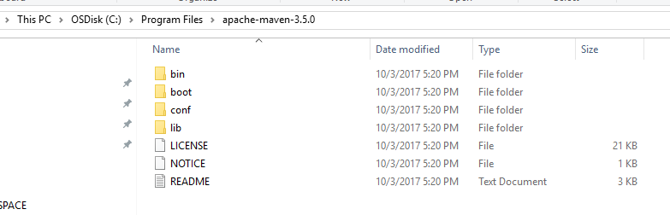

4.Then we need to set the Maven Environment path:

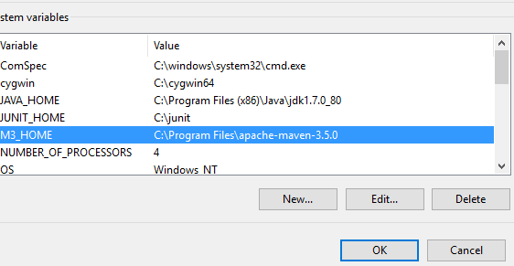

5. We also need to add the Maven Directory Path to the System path

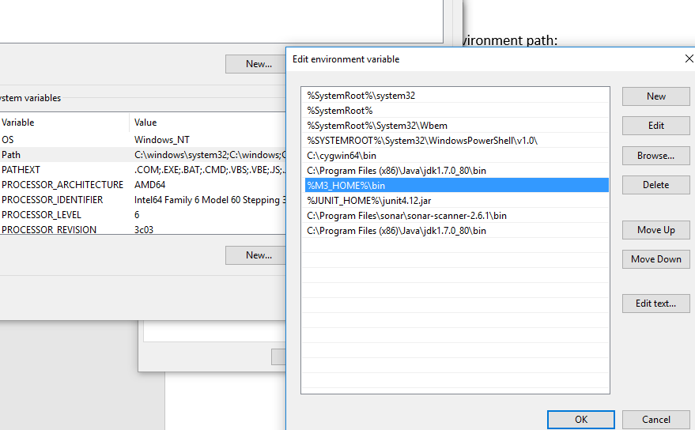

6. In order to confirm whether Maven is Successfully installed in your installed or not we should verify it in the command prompt with the help of the command **mvn -version**

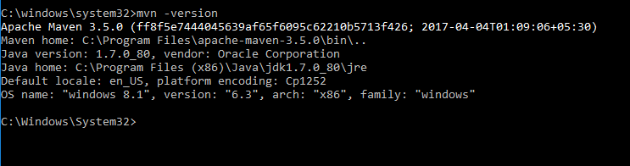Thus Maven is successfully installed in your system.

**JUNIT INSTALLATION**

[**JUnit**](http://junit.org/) is a unit testing framework for the Java programming language. JUnit has been important in the development of test-driven development, and is one of a family of unit testing frameworks. Its main use is to write repeatable tests for your application code units. It basically emphasizes on setting up the test data for a piece of code that can be tested first and then implemented. Thus, increases the productivity of the programmer and the stability of program code, which in turn reduces the stress on the programmer and the time spent on debugging.

**Why do we use JUNIT**

1. JUnit is an open source framework, which is used for writing and running tests.
2. It provides annotations to identify test methods.
3. Provides test runners for running tests.
4. JUnit tests allow you to write codes faster, which increases quality
5. JUnit tests can be run automatically and they check their own results and provide immediate feedback. There's no need to manually comb through a report of test results
6. JUnit is elegantly simple. It is less complex and takes less time.

**INSTALLATION**

1. It is necessary to have JAVA installed in the system to download JUNIT Archive. Check if it is installed or not and if not install it.
2. Install JUNIT Archive from the link - [**http://www.junit.org**](https://github.com/downloads/junit-team/junit/junit-4.10.jar)
3. Save it under C drive

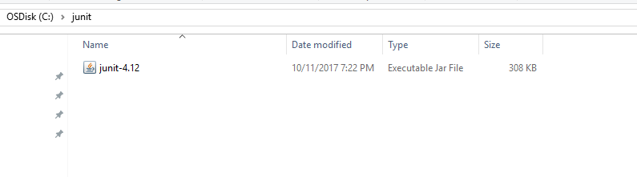

1. Set the **JUNIT_HOME** environment variable

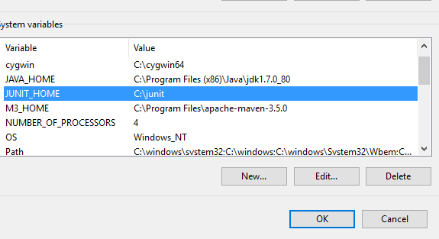

1. Now set the path also to the system path as follows :

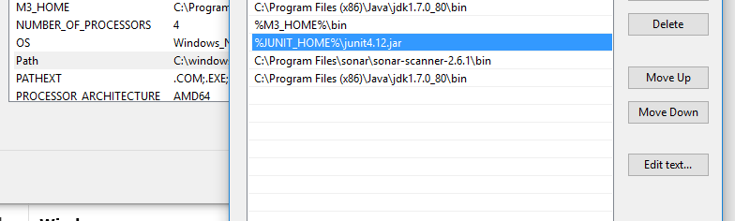

|  |  |
| --- | --- |
|  |  |

Thus , **JUNIT** installation is complete.

**INSTALLATION DECK**BY

ANINDITA ROYCHOWDHURY